1. Create a bash script to execute **if-else condition.**

Step 1: create a file with shell name as extension



Step 2: Enter the Script

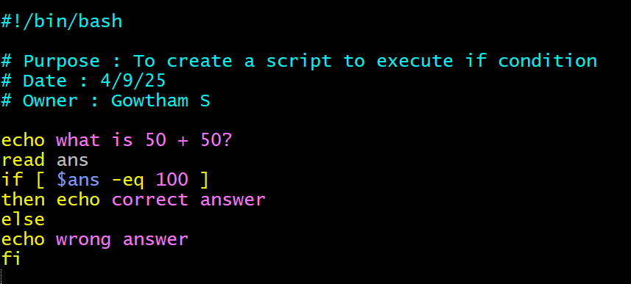

Step 3: Give execute permission to the file



Step 4: Execute it using **./filename.shell**

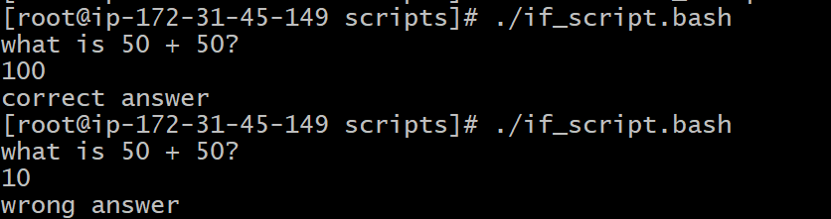

1. Create a bash script to find if file exists or not

Step 1: create a file with shell name as extension



Step 2: Enter the Script

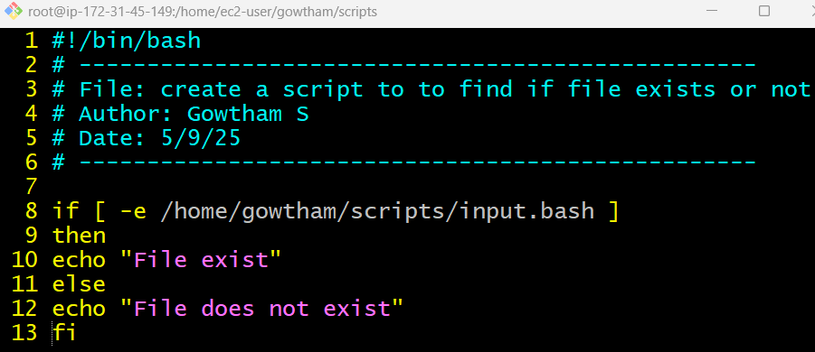

Step 3: Give execute permission to the file



Step 4: Execute it using **./filename.shell**



1. Create a bash script to execute case statements

Step 1: create a file with shell name as extension



Step 2: Enter the Script

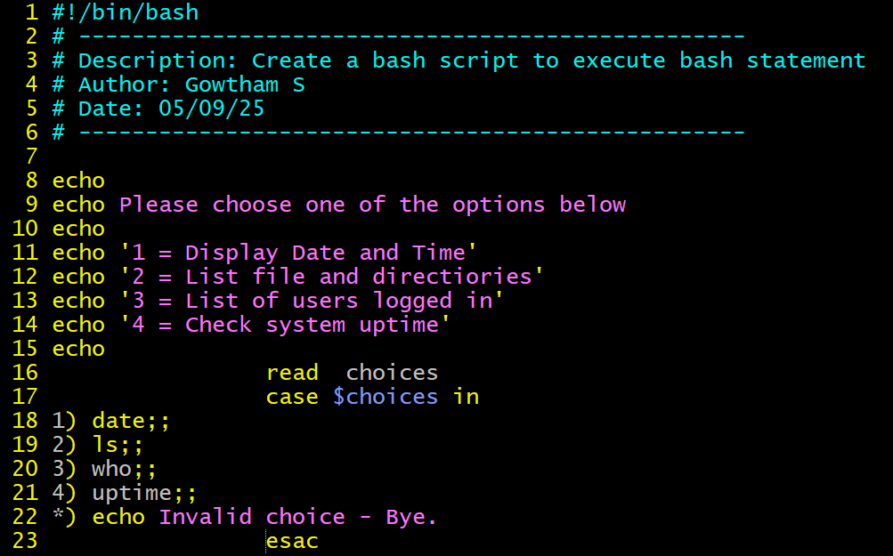

Step 3: Give execute permission to the file



Step 4: Execute it using **./filename.shell**

